Decolonisation in Leadership and Identity

Marne’ Swanepoel
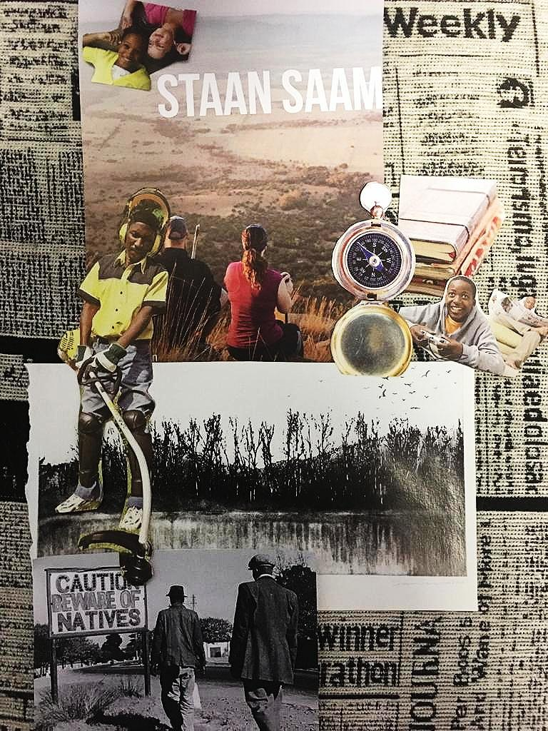

Abstract
This essay explores different theories surrounding visualities and counter-visualities as seen in artworks and forms of popular media. It argues that these forms of media can be used to either perpetuate or combat Colonisation in Modern South Africa. The leadership persona’s role in Decolonisation is also discussed as they can use their influence to encourage other to re-establish their identities.

This essay sets out to showcase an understanding of the construct of Colonisation and Decolonisation by discussing the impact of Colonisation and the role leaders play in leading Decolonisation in modern South Africa. It reflects on the arguments made by Juan-Pierre van Der Walt on the leadership persona and Amanda du Preez’ argument on the effect that visualities have on the African perspective. Visualities are further discussed in line with Nicholas Mirzoeff’s The Right to Look which takes a deeper look at visualities and countervisualities. Next, it reveals how landscape paintings are used to combat manifestations of Colonisation in modern society. It investigates the importance of the past by looking at the different ways that contemporary South African artists such as William Kentridge create a counter-history against colonial myths such as terra incognita and terra nulla, as defined by Miriam Aronowicz, to contest the colonial gaze.
It is important to note that Colonisation and Decolonisation are not dichotomies. The Oxford dictionary defines Colonisation as the action or process of settling among and establishing control over the indigenous people of an area. Colonisation is said to enforce cultural and social control and assimilation. In other words, Colonisation is not simply the process of colonising and claiming rights to the sovereignty of a country, it expects the individuals of a country to completely assimilate to their ways. Colonisers reject the identity of the colonised by enforcing their identities onto them. In Contesting the South African Colonial Landscape, Miriam Aronowicz (2009:1) emphasises the connection between land and identity. She believes that the South African psyche and sense of place are connected to the landscape and habitat.
Decolonisation is defined in the Oxford dictionary as the action or process of a state withdrawing from a former colony, leaving it independent. Through this process the colonisers claim back their sovereign right to independently own their identities that the status quo developed by the colonised country has removed. However, Decolonisation is more complex than simply taking back the right to govern a country independently, it is about finding an identity that has been stripped by Colonisation. Decolonisation involves a process of re-establishing identity, often as a mixture of a previous identity and the colonial identity.
Mirzoeff (2011:11) states In, The Right to Look, that slavery can be seen from both a literal and a metaphorical perspective. It can either involve physical trauma caused by actual practices of slavery or it could exist as an expression of a technically ‘free’ social relation that is felt to be metaphorically equivalent to slavery. He describes the ordering of slavery by means of visual technologies and surveillance under the headings of mapping, natural history, and the force of law. This illustrates how Colonisation is manifested in Modern society. It is more subtle than old forms of Colonisation involving slavery, but it is those old practices that still perpetuate a certain mindset in modern South Africa. Leadership persona is an important aspect of decolonisation in leadership. Van der Walt (2018:1) writes in, All About me: Intersections between digital humanities and representations of the self, about the leadership persona as a platform for self-presentation. Before considering the role of the leadership persona as a performance, it is important to understand leadership and persona separately first. Van der Walt (2018:2) mentions that leadership is when personae engage with others in a way that leaders facilitate a course of action that coincides with followers with a specific or general goal in mind. A leader can thus be defined as someone who actively engages with others to affect their actions and doctrine. A leader enforces action. Van der Walt (2018:2) also discusses the concept of persona as a mask that individuals incorporate in their identity performance. This persona or mask serves to convey selected aspects to an audience.
The decision of which aspects to convey is heavily influenced by social climate. As social construct, van der Walt (2018:4) notes how leadership is influenced by public surroundings and how it consequently needs to be maintained to meet the needs of the micro public. It is important to take note how the social influence of the persona causes leadership to develop. It can be argued that the importance of social influence and the public draws similarities between leadership and celebrity.
The definition of celebrity in English is, the state of being well known. It can be said that one has an influence on others when one is well known as everyone is aware of your actions. Often in a leadership position one finds oneself constantly under the public eye. Van der Walt (2018:5) affirms that leadership personalities find themselves on the avenue of celebrity as their actions are highly visible and are often discussed on the news. It is this focus on the public domain that causes the manifestation of a leadership persona that the leader uses to present certain characteristics to the public that will showcase their favourable qualities. In a sense, a leadership persona is a different form of re-establishing an identity as re-establishing does not necessarily mean to establish something anew but can be used to establish something again. The leadership persona establishes the leader’s noteworthy qualities again to bring them to the public’s attention. Leaders pave the way towards the Decolonisation of modern South Africa by using their influence to inspire the public to re-establish their identities.

Ways of decolonising can be interwoven in art and other popular forms of media that mediates history and news. In 2015 student-led protests began as a plea for government intervention in a national transformation known as the fallist movements. One of their goals was to stop increases in student fees. This movement is known as the FeesMustFall movement. Van der Walt (2018:1) mentions how social media was the predominant platform on which the #FeesMustFall campaign was presented. Social media is a popular platform used to influence people, but it is not the only way to assert influence. In, The Marikana Massacre: Seeing it All, Amanda du Preez raises concern about representation and how it can be manipulated to fit a certain narrative. Du Preez (2015:3) exposes the scopic regimes at work in representations that aim to interpret the Marikana event. The Marikana Massacre started as a strike at a mine in the Marikana area but took a lethal turn as the South African security forces opened fire on the strikers. Du Preez brings up Judith Butler’s “frame theory”. The “frame theory” explains how different ways of representation such as the media can be used to manipulate the interpretation of the viewers and structure their experiences of images. According to du Preez (2015:3) contemporary South African visual culture assists in framing responsiveness to the impinging world as it already guides interpretation in many instances. Visuals in art can influence people and can have a great effect on the African perspective. The possibility of using art to serve as visual activism is mentioned by Du Preez (2015:437). She states that art often acts as a voice of protest to answer the unrepresentability.

In, Terra nulla: Contesting the South African colonial landscape, Miriam Aronowicz (2009:2) discusses how colonisers used landscape painting to claim power over the landscape. South Africa’s problematic history of Colonisation is tied to the nationalisation of land. In conjunction with this Mirzoeff affirms that visuality naturalises the association the authority has with power. According to Mirzoeff (2015:6) Modernity is a European phenomenon as it challenges the claimed inevitability of the hegemonic means in which current history frames the present. Which means in order to engage with visuality in the present or past one needs to establish its counterhistory. Mirzoeff states that visuality is a supplement that makes a self-authorizing of authority seem self-evident. Landscape painting was dominated by European conventions. Aronowicz (2009:1) writes how scenes of a romanticised South African landscape were created by Europeans for Western audiences as their images were embedded with a problematic colonial gaze.
Du Preez (2015:436) agrees with Wagner-Paciﬁci in stating that historical events are restless and unstable in terms of interpretations and meanings that are associated with them as there are countless representations of an event. Artistic media such as paintings, photographs and sculpture, provide representations that differ from ofﬁcial representations via mapping, documentaries, and forensic photography. Artistic media can be utilised as a tool to renegotiate a different perspective. Modern and contemporary South African artists use the medium of landscape painting as a tool to renegotiate space and place in the country’s post-apartheid terrain. Well known South African landscape artists such as Jacobus Hendrik Pierneef and Jan Ernst Abraham Volschenk paint South African landscapes in a way that portrays colonial spaces. They achieve this by representing the landscape as terra incognita and terra nulla. The colonial myth that the land is empty upon discovery is encapsulated within the terra incognita. According to Aronowicz (2009:6) this can be seen in Pierneef’s paintings of Rustenburg Kloof as he represents it as an empty space with no visual markers of trauma or signs of the displacement of people. This colonial space is also terra nulla, as it becomes an empty landscape scene, an open background on which progress and modernisation can start to develop. By painting South African landscapes as empty spaces devoid of any meaning is to paint it as terra nulla and terra incognita. By doing this the artist successfully colonises the landscape by reinforcing a primitive paradigm as it suggests that the South African landscape was empty upon discovery and therefor justifies colonising the land.
Mirzoeff (2011:14) explains that certain visualities are used to maintain the colonial environment but that a countervisuality can visualise a different reality which is modern as well as decolonised. Contemporary South African landscape artists start to reclaim space and to break down colonial myths by problematising the terra incognita and terra nulla embedded in colonial paintings. Although the colonial space is empty, it is not devoid of meaning. The role of the contemporary landscape artist is to reactivate the meaning and memories through counter-histories. These counter-histories are a type of countervisuality. Mirzoeff (2011) highlights the ways in which countervisuality can rupture visuality’s hegemony by providing context for decolonising the genealogy of visuality. These counter-histories are post-memories of traumatic events that are re-inscribed onto the space of the land emptied through colonial art history. South African artist, William Kentridge, uses his landscape paintings to critique South Africa’s tormented history. Kentridge’s leadership persona is expressed through his art as he focuses on forgetting and remembering and how they are closely intertwined. He believes that even though the past may fade into the background of our minds, our identity remains shaped by this forgetting. Kentridge’s drawings echo the political climate of his time. His art confronts the viewer with issues of the past. It can be argued that his art educates the viewer about the unromanticised past of South Africa. He uses a technique which he calls “disremembering”. He draws layers of drawings on top of each other after rubbing out parts of the previous drawing. This technique is a metaphor for Kentridge’s belief that memories and myths must be exposed and recorded before South Africa can become a democratic space. Kentridge’s past has determined what difference he wishes to bring to society and has therefore shaped his leadership persona in the present. Du Preez affirms that the landscape is an important element in the visual composite of events as it is a place to return to in remembrance. She references to the terra nulla when she explains that even though it might seem like there is nothing to be seen, the landscape renders incidents visible. Kentridge created his Colonial Landscape series in 1995. This is the same year that South Africa began deconstructing its national history of apartheid with the beginning of Truth and Reconciliation Commissions. This assembly was vital to the transition of South Africa into a democratic state.
Any image of landscape always represents itself as well as something else. Issues of race, class, and gender are always interwoven and encoded into the physical terrain. This is demonstrated by the postmodernisation of the landscape. Du Preez delves into the democratic politics of countervisuality by highlighting that there might be biased assumptions of claiming the right to look. Similarly, van der Walt’s (2018:4) creation of the leadership persona is a biased process that is influenced by the leader’s social environment. Du Preez uses the example of the Marikana incident and how there was a difference between independent eyewitness reports and the ofﬁcial ANC version manifested in police reports. Visibility is thus a powerful political instrument due to the rise of technology and communication media. The importance of technology and communication media is also highlighted by van der Walt (2018:4). He suggests that leaders create online avatars to perform their persona in an online social environment. This makes it easier for the leader to reach a wider audience and gain a bigger following. Countervisualities challenge visualities and are used to break down the accepted norm by presenting facts. This allows the decolonised to reclaim authority to re-establish identity.
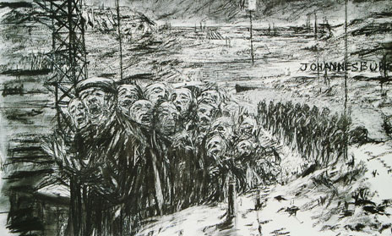

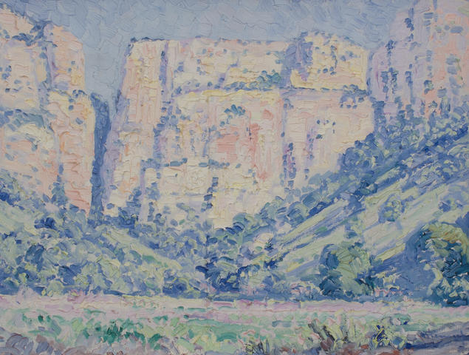
Figure 1: William Kentridge, Johannesburg, 2nd Greatest City After Paris, 1989. Film, 35 mm, shown as video, projection, black and white, and sound (mono), Duration: 8min. Tate Museum, London. (www.tate.org.uk)

Figure 2: Jacob Hendrik Pierneef, Rustenburg Kloof, 1931-2. Oil on canvas, 35.5 x 46cm. (www.bonhams.com)

As mentioned before, leaders play an important role in decolonisation. Contemporary South African artists take on a role of leadership by revolutionising the landscape artform to assist in re-establishing identities that have been lost through years of repression due to colonialism.
Leaders need to reject the identity that has been forced onto them to inspire authenticity in others. Mirzoeff’s (2011:1) theory involving the right to look is not about seeing as it does not claim individualism or voyeurism. It is about claiming autonomy. He writes about slave plantations that were the first domains of visuality as they were monitored by the overseer who operated as the surrogate of the sovereign. English historian Thomas Carlyle used the term visuality to refer to what he called the tradition of heroic leadership. In order to sustain autocratic authority, heroic leadership visualises history. It can be argued that the leader plays an important role in visualising which is the production of visuality. The production of visuality involves the processes of making ‘history’ perceptible to authority. It could be said that leadership involves visualising the history by helping others claim the right to look.
Mirzoeff (2011:5) defines the “realism” of countervisuality as the means by which one tries to make sense of the unreality created by visuality’s authority whilst simultaneously proposing a real alternative. He stresses that unlike other forms of realism, this form is not a depiction of lived experience. Instead, it depicts existing realities and counters them with a different realism. He proposes two choices. The one being continuing to move on and authorizing authority and the other, claiming that there is something to see and democratizing democracy. This statement echoes the words of Kentridge that in order to become a democratic country South Africa needs to face its dark past.
Mirzoeff (2011:4) states that working and subaltern classes understand that education is their paramount means of emancipation as education was a practical way of moving on from work that has been allocated to a specific individual. Separation was countered by democracy thereby proving that the right to look correlated with the right to be seen. As mentioned before, leaders become celebrities as they are constantly under the public eye. This means that their actions influence those around them. Leaders play an important role in issues such as Decolonisation as they can use their influence to educate and to encourage others to take part in movements such as the integration of memory onto landscapes. Kentridge uses his art to educate people about the past. The importance of educating others about the effects of Colonisation in Modern South Africa should be noted. Leaders need to use their influence to educate their followers. This means that leaders need to make sure that they themselves remain educated and understand these concepts. Leaders need to gain insight by reaching out to the public so that they can consider a variety of perspectives of any given situation.
Mirzoeff’s (2011:3) idea of the hero is an individual who aims to be a leader of the post monarchical nation-state. Visuality appropriated the revolutionary tactic of the national hero as leader to reclaim the altered terrain of history into a renewed system of domination. This can become problematic as it is a visualisation of a revived sovereignty that might perpetuate the same mistakes of the past. As reality is subjective, one needs to find how one can shape one’s own reality in a way that does not sustain problematic and unjust systems.
It can be concluded that individuals in power can use their position to sway the opinion of the public. Leaders need to encourage the public to claim their right to look and to see things from different perspectives before committing to a certain narrative. This is one of the first steps towards envisioning a Decolonised future.

In the past certain people were denied the right to look. Popular platforms such as social media and art has been utilised to reclaim the right to look. However, these mediums are often used to sway the public towards a certain opinion. Visibility is thus a powerful political instrument due to the rise of technology and communication media. These platforms can be used to counter such propaganda and to share different perspectives to a certain issue. Therefore, the same methods used to enforce Colonisation can be altered to drive Modern South Africa towards a decolonised future. By studying different theories, it becomes apparent that anti-visualities can be inscribed into texts to regain autonomy. Visualities therefore “democratize democracy”. Leaders are seen as celebrities in Modern times. They need to use their influence to educate others about the issues of the present as well as the mistakes of the past. This education will inspire a different way of looking, a way of looking from different perspectives to gain some insight and to remember the dark past so that the future can avoid making the same mistakes. Leaders create a leadership persona in order to showcase their best qualities to their followers, they need to inspire others to work on and to showcase their best qualities as well. Art is used to re-establish identity by emphasising remembrance and for creating an inclusive future. These counter-histories are a type of countervisuality. In other words, Decolonisation is not about reverting to the past completely but about finding a way to move forward by keeping the past in mind. It can be argued that by using popular media South Africa can remain globally relevant whilst becoming a decolonised nation.

References
Aronowicz, M. 2009. Terra nulla: Contesting the South African colonial landscape. University of Toronto Art Journal 2:1-25

Du Preez, A. 2015. The Marikana masacre: seeing it all. Safundi The Journal of South African and American Studies 16(4): 419-442.

Mirzoeff, N. 2011. The Right to Look. 1st ed. North Carolina: Duke University Press

Van der Walt, J. (2018). The Leadership Persona: A Platform for Self-Presentation. In: A Du Preez, ed., All About me: Intersections between digital humanities and representations of the self, 1st ed. Pretoria.

